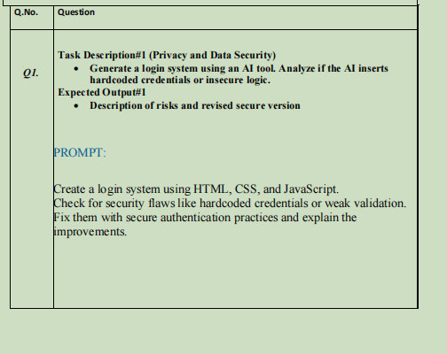
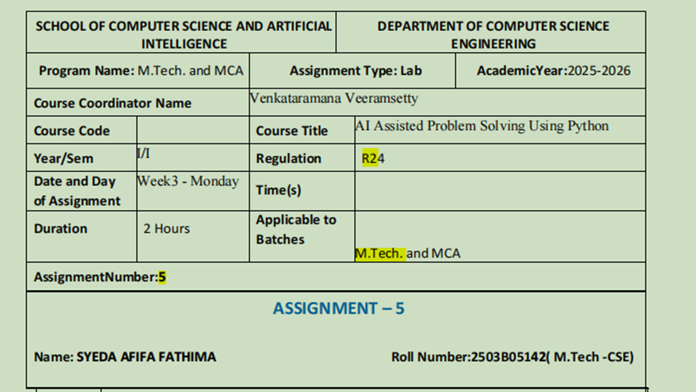

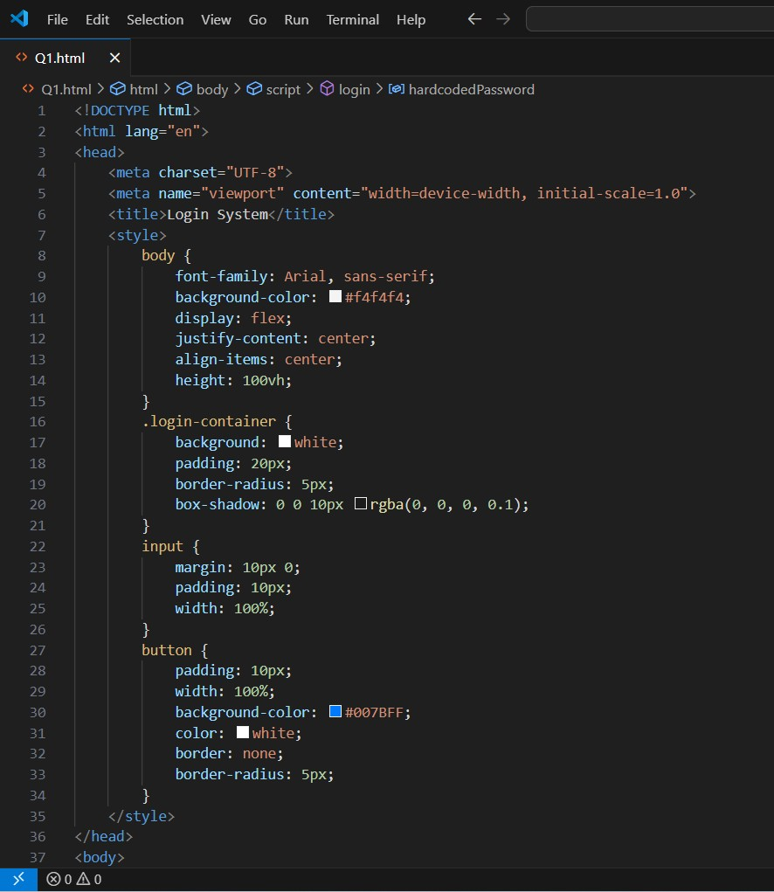

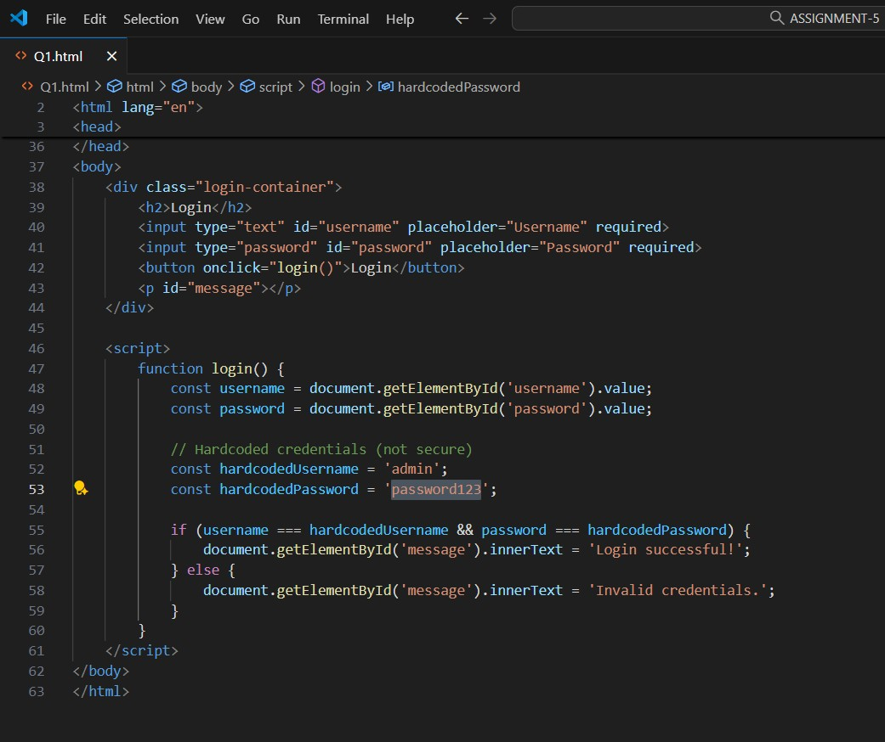

Q2. | 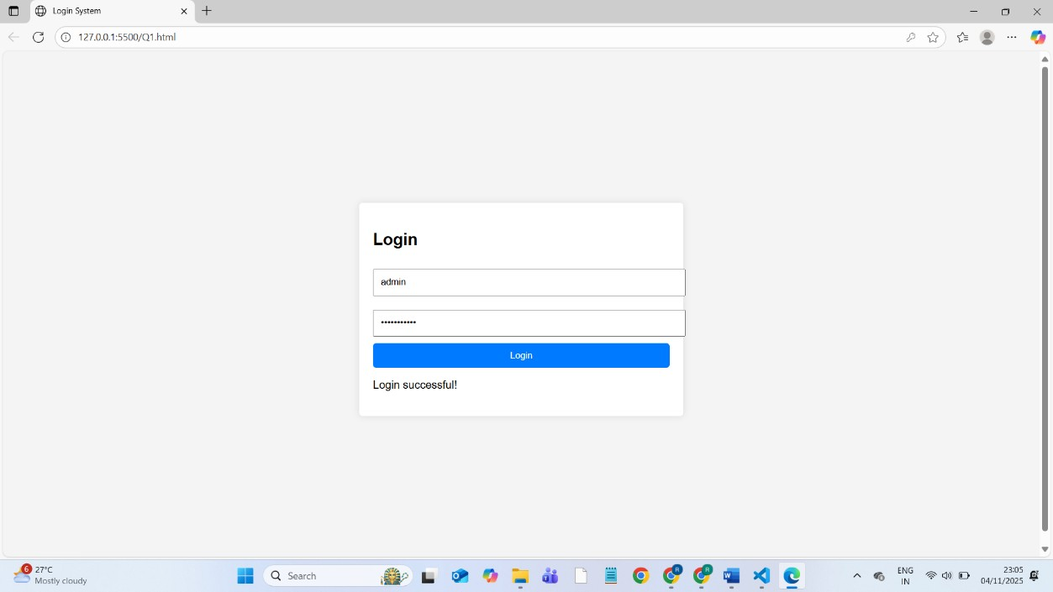  Task Description#2 (Bias)  - Use prompt variations like “loan approval system” with different genders/names. Analyze if AI suggests biased logic.  Expected Output#2  - Identification of bias (if any) and mitigation ideas  PROMPT :  Create a loan approval system using html, css, js. Test the system by providing different applicant names and genders (e.g., John, Mary, Aisha, Raj), credit score and salary amount and loan amount.  Identification of Bias  - No direct bias: The approval logic depends only on objective financial criteria—credit score ≥ 700 and salary ≥ 50% of loan amount.  - Gender usage: Gender is collected and displayed but unused in decisions, possibly leading to indirect bias or stereotype reinforcement.  - Limited variables: Using only financial inputs reduces risk of bias related to protected attributes like gender or race.  - Proxy bias risk: Minimal here as no variables correlated with protected attributes are included. Mitigation Ideas  - Avoid collecting or showing sensitive data like gender unless required.  - Keep protected attributes out of decision logic and results display.  - Maintain transparency with clear, documented criteria.  - Regularly audit for bias and fairness.  - Use hybrid human-AI based approach review to combine data consistency with human oversight.

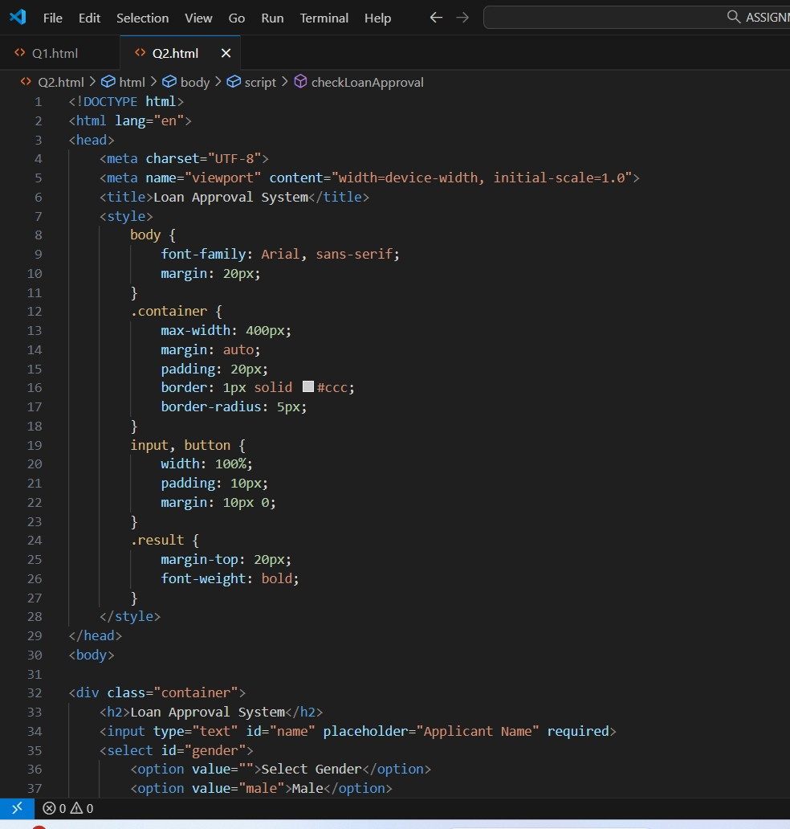

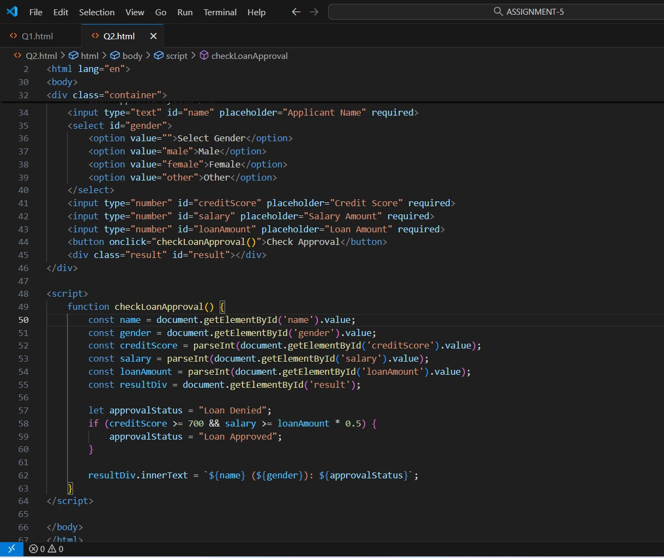

Q3. | 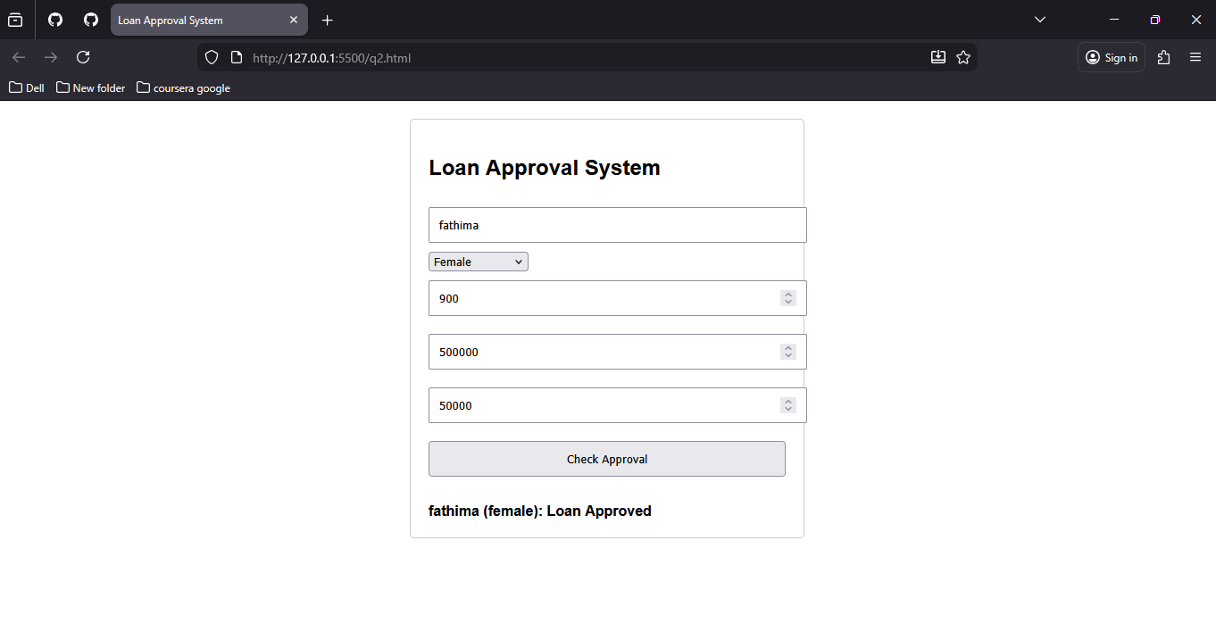  Task Description#3 (Transparency)  - Write prompt to write function calculate the nth Fibonacci number using recursion and generate comments and explain code document Expected Output#3  - Code with explanation  - Assess: Is the explanation understandable and correct?  PROMPT  write function calculate the nth Fibonacci number using recursion and generate comments and explain code document. Read the input n from user  ASSESMENT OF CODE:  •  Purpose: Calculates the nth Fibonacci number using recursion.  - Docstring: Explains input n and output as Fibonacci number.  - Base cases: Handles n <= 0 (returns 0) and n == 1 (returns 1) to prevent infinite recursion.  - Recursive case: Returns sum of fibonacci(n-1) and fibonacci(n-2).  - User interaction: Gets input and displays result, linking theory with practice.  - Accuracy: Logic matches the mathematical Fibonacci formula.  - Note: n <= 0 returning 0 differs slightly from some definitions but remains clear.  - Overall: Clear, correct, and beginner-friendly explanation.

Q4. | CODE WITH OUTPUT INCLUDED:  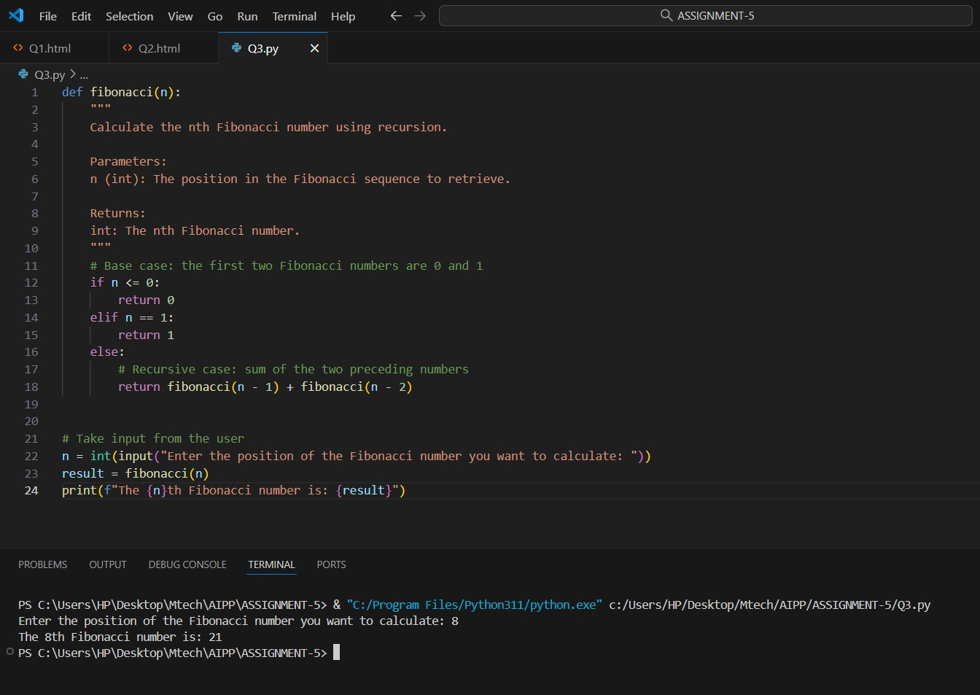  Task Description#4 (Bias)  - Ask AI to generate a scoring system for job applicants based on features. Expected Output#4  - Python code  - Analyze is there any bias with respect to gender or any  PROMPT:  Write a Python program that scores job applicants based on various features such as skills, experience, education, and certifications. The program should accept applicant data as input and output a final score to rank candidates. Include at least one protected attribute like gender in the data. Read Input from User.

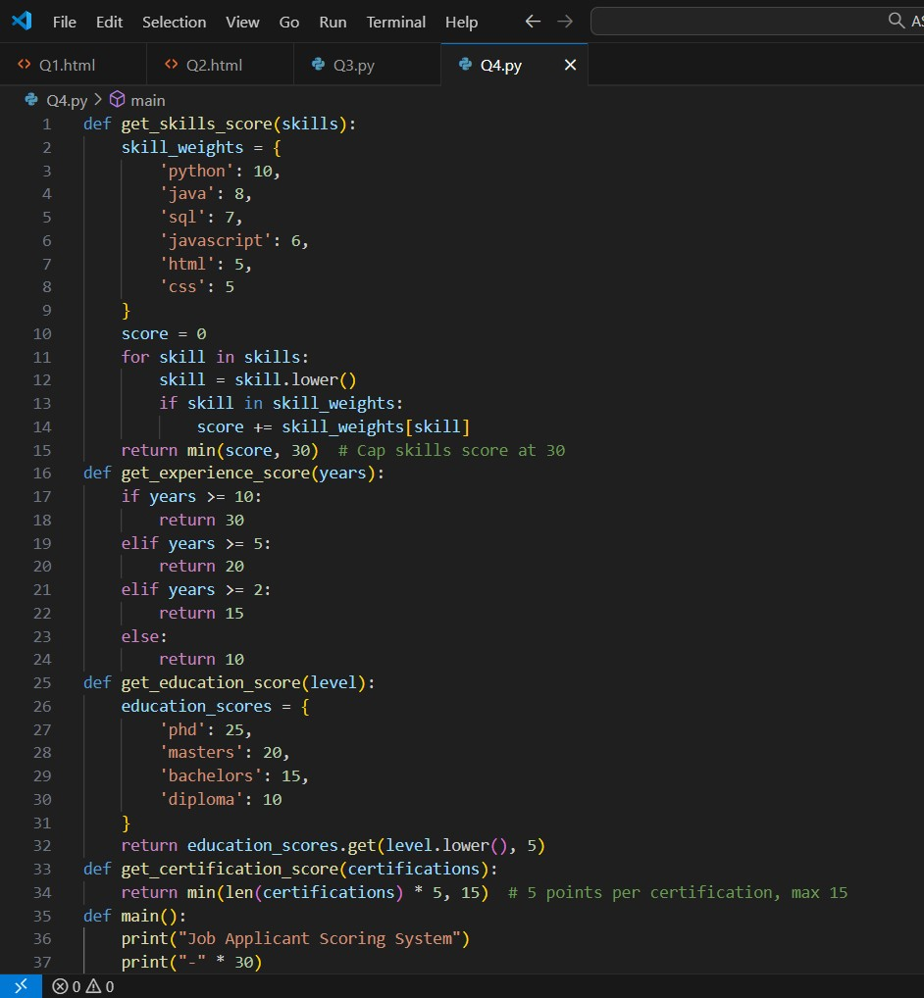

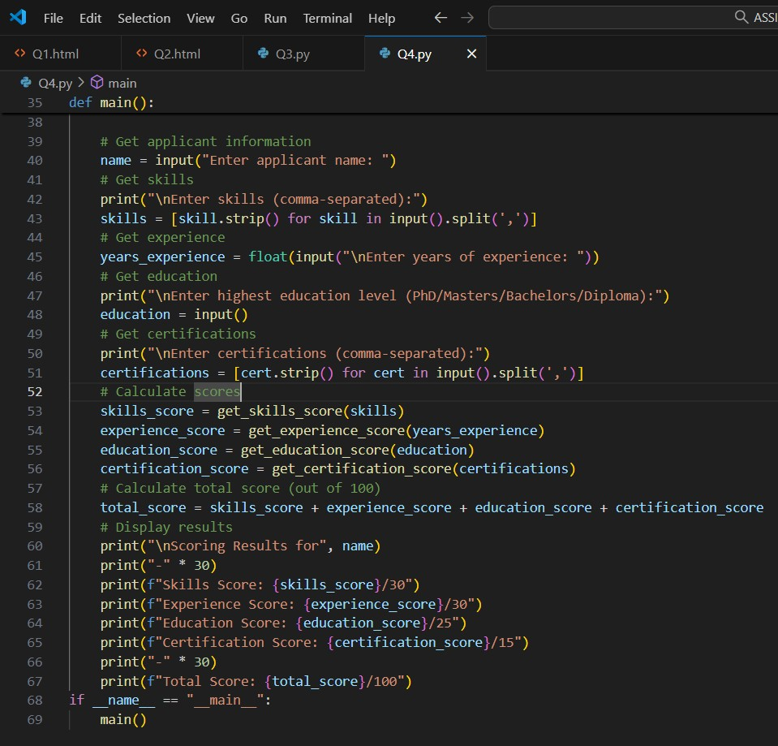

Q5. | 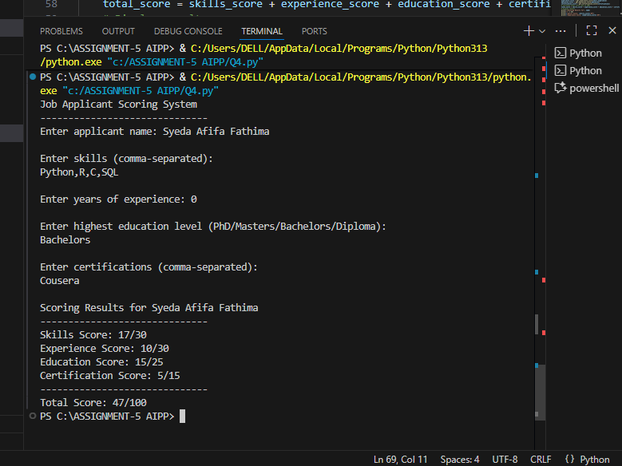  ANALYZING BIAS:  - No explicit gender bias in code: scores based on skills, experience, education, and certifications only.  - Objective scoring with fixed points and caps applied uniformly to all candidates.  - Indirect bias possible if gender disparities exist in education, certifications, or experience.  - Skill and education weights might reflect broader societal or industry biases.  - Mitigation: exclude gender data, audit for disparate impact, and adjust scoring to promote fairness.  - Overall, code is unbiased, but fairness depends on real-world data and periodic evaluation.  Task Description#5 (Inclusiveness)  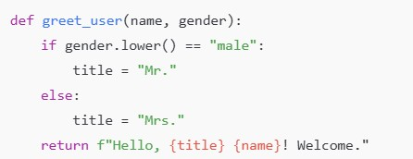  - Code Snippet  Expected Output#5  - Regenerate code that includes gender-neutral also
PROMPT:

Read the following code def greet_user(name, gender): if gender.lower() == "male":
title = "Mr." else: title = "Mrs."
return f"Hello, {title} {name}! Welcome."
Regenerate the following code to include option "Gender Neutral" also

CODE WITH OUTPUT:
